**Ideation Phase**

**Define the Problem Statements**

|  |  |
| --- | --- |
| Date | 22 September 2022 |
| Team ID | PNT2022TMID31901 |
| Project Name | Estimate the crop yield using data analytics |
| Maximum Marks | 2 Marks |

**Customer Problem Statement :**

Problem Statement-1 :

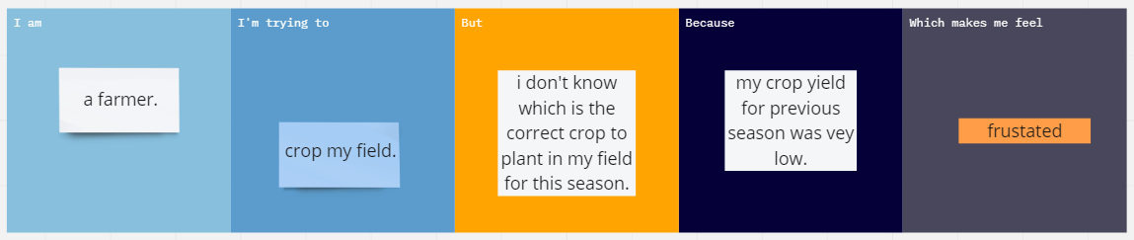

Problem Statement-2 :

